2024 awards from the Catholic Media Association for
Publications of the National Religious Vocation Conference VISION & HORIZON

Spanish: Best Special Supplement or Special Issue
Second Place
Bases de la vocación (Vocation Basics: Essentials for the vocation journey)
VISION Vocation Guide, TrueQuest Communications for the NRVC
By VISION editors
Judges’ comments: This supplement provides useful editorial information regarding a religious vocation.

Best Feature Article –Professional and Special-Interest Magazines,
Including Clergy and Religious
Second Place
The vow of celibacy in real life
HORIZON, Journal of the National Religious Vocation Conference
By Sister Julia Walsh, F.S.P.A.; Father Kevin Zubel, C.Ss.R.; and Sister Romina S. Sapinoso, S.C.
Judges’ comments: These first-person narratives give unique insight into the responsibilities, rewards and challenges of
taking a vow of celibacy. Each testimony is honest, revealing and powerful.

Best Writing, Analysis – Magazines
Third Place
Synodality and new life
HORIZON, Journal of the National Religious Vocation Conference
By Carol Schuck Scheiber
Judges’ comments: This in-depth examination of synodality offers thoughtful insights for religious communities
seeking to attract new members. It is well-informed, concrete and clearly structured

Best Essay – Professional & Special-Interest Magazines,
Including Clergy and Religious
Third Place
Celibate chastity: sacrifice because of the kingdom
HORIZON, Journal of the National Religious Vocation Conference
By Father Douglas-Adam Greer, O.P.
Judges’ comments: Clear, compelling writing that shines thanks to the
personal, heartfelt examples and practical tips.

Spanish: Best Reporting on Vocations to Priesthood, Religious Life, or Diaconate
Honorable mention
Religiosos en un limbo juridíco (Religious seekers in legal limbo)
VISION Vocation Guide, TrueQuest Communications for the NRVC
By Miguel Naranjo, Graciela Mateo and Traduccion de Monica Krebs

Extra: Links to VISION’s award-winning “Vocation Basics” handout in English and Spanish. Includes religious life basics and timeline.

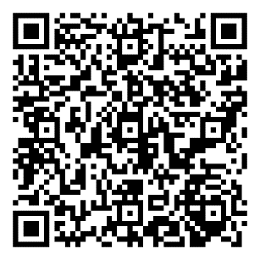

https://nrvc.net/328/publication/4459/article/27824-nrvc-publications-earn-5-awards

